1. Write a C++ program to read and print student information using two classes and simple inheritance. Define a class named ***StudentBasicInfo***, and declare the name, age, and gender of the related student as basic information. Then, your second class, ***StudentResultInfo***, should be inherited from ***StudentBasicInfo***. In this class, the user should enter the student's total marks and calculate the percentage of the student’s grade. In the main function, you should get the student's basic and result information by using inheritance. Consider the sample run given below.

**Sample Run:**

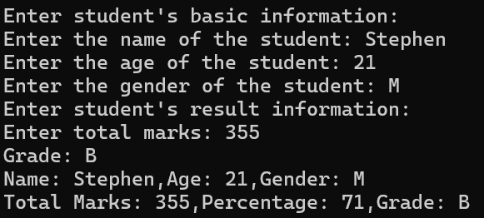

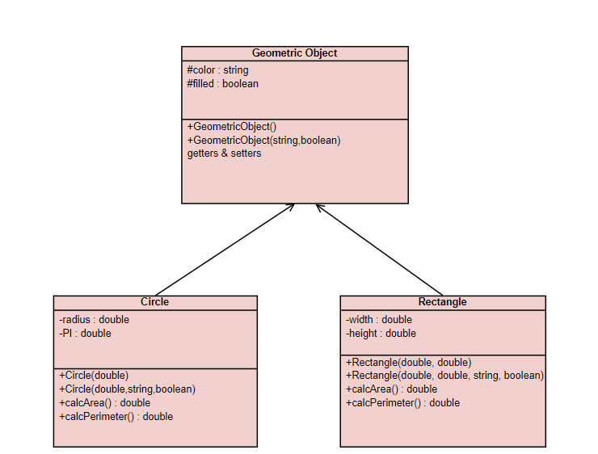

Suppose, you want to design the classes to model geometric objects such as circles and rectangles. Geometric objects have many common properties and behaviors. They can be drawn in a certain color, filled, or unfilled. Thus, a base class ***GeometricObject*** can be used to model all geometric objects.

The ***Circle*** class inherits all accessible data fields and methods from the ***GeometricObject*** class. In addition, it has a new data field radius and its associated methods.

The ***Rectangle*** class inherits all accessible data fields and methods from the GeometricObject class. In addition, it has new data fields width and height and its associated methods.

In the main function, create a Circle and a Rectangle object and uses *calcArea()* and *calcPerimeter()* methods of related objects to display the following output.

**Sample Run:**

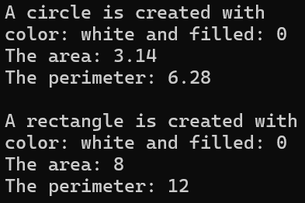

1. Create a base class ***Vehicle*** that includes the following properties:

* brand (string)
* model (string)
* year (int)

The ***Vehicle*** class should have a constructor to initialize these properties, a destructor, and a member function *displayInfo()* that prints these properties.

Design a derived class ***Bicycle*** that inherits from the ***Vehicle*** and includes an additional property:

* hasGears (bool)
* Implement a function *displayInfo()* that calls the base class function to print the vehicle’s brand, model, and year, then prints whether the bicycle has gears or not.

Design another derived class ***Scooter*** that also inherits from the ***Vehicle*** and includes an additional property:

* motorPower (int)
* Implement a function *displayInfo()* that calls the base class function to print the vehicle’s brand, model, and year, and then prints the scooter’s motor power in watts.

In the main function,

Create an object from the ***Bicycle*** and ***Scooter*** classes, then call the *displayInfo()* function for each object to display the information about the bicycle and the scooter.

**Sample Run:**

